***Microsoft Power Automate Tips and Tricks***



Table of Contents

1. Introduction…………………………………………………………………………………………………….........3
2. Flow Tips and Tricks…………………………………………………………………………………………………4
3. Reduce the number of Flow variables……………………………………………………………………..4
4. Make Use of Scope Action……………………………………………………………………………………….5
5. Use the Rename, Comments and Notes Option……………………………………………………….7
6. Using the Select Operation………………………………………………………………………………………8
7. Use Templates to Create Flows………………………………………………………………………………..9
8. Skip Option in Power Automate……………………………………………………………………………..11
9. Search Connector Option in Power Automate…………………………………………………………12
10. Copy to Clipboard Option……………………………………………………………………………………….14
11. Testing the Flows……………………..…………………………………………………………….………………15
12. Share the Flow with Other Users…………………….………………………………………………………16
13. Making use of Nested if Statements in Power Automate Flows…………..………………….16
14. Option to set the Pagination limit and timeout…………….…………………………………………17
15. Error Handling……………..………………………………………………………………………………………….18
16. Experimental Features in Flow………………………………………………………………………………..20
17. Export and Import Flow…………………………………………………………………………………………..21
18. Flow Checker………………..…………………………………………………………………………………………22
19. Use Compose Action……………………………………………………………………………………………….22
20. Commonly Used Expressions to Access Values………………………………………………………..23
21. Parallel Branching……………………………………………………………………………………………………23
22. Concurrency Control………….……………………………………………………………………………………24
23. Flow Trigger Conditions…………………………………………………………………………………………..25
24. Use Peek Code to Copy the Expressions………………………………………………………………….26
25. Number and Currency Formatting in Flow………………………………………………………………27
26. Date and Time Formatting and Converting Time Zones in Flow………………………………28
27. Flow Run History…………………………………………………………………………………………………….29
28. Document Version History………………………………………………………………………………………30

***Introduction***

Microsoft Power Automate is a cloud-based service. It is one of the most efficient ways to automate tasks between a number of online services. It helps in automation in various services like Microsoft SharePoint, OneDrive , Excel Online and a lot more. It has a over 370 connectors through which we can perform a number of automations.

This document notes few of the important tips and tricks that can be useful to developers when working with Microsoft Power Automate.

*Flow Tips and Tricks*

# **Reduce the number of Flow variables**

Whenever we have a requirement to initialise a lot of variables say 4 or more than that, we can make use of the initialise variable action and use an object to define a number of variables. This is an extremely useful action in Power Automate which helps to reduce the number of variables and eventually the flow length.

The same has been depicted in the screenshots with example.

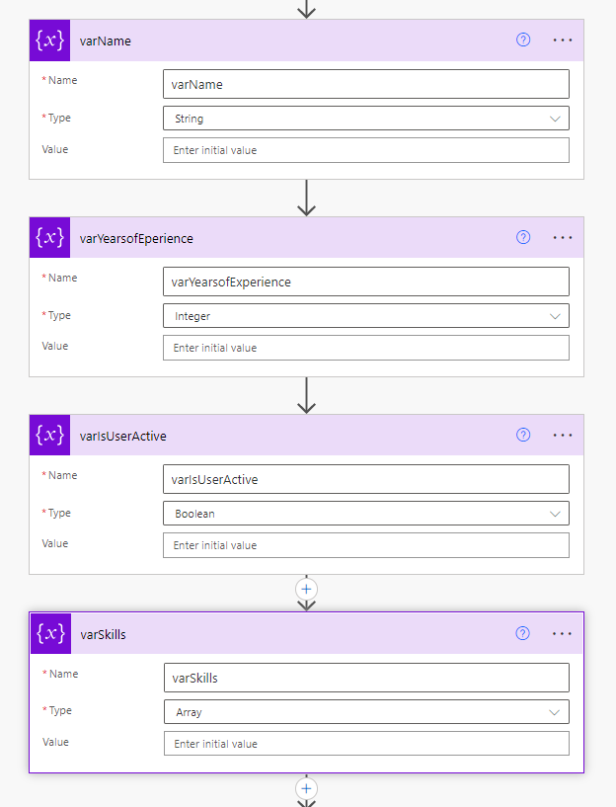**Screenshot 1.** Initialising 4 different variables

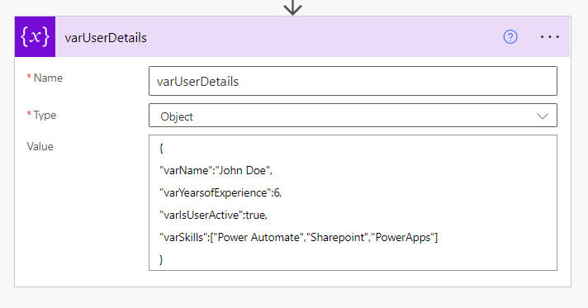

**Screenshot 2.** Initialising an object variable with four variables

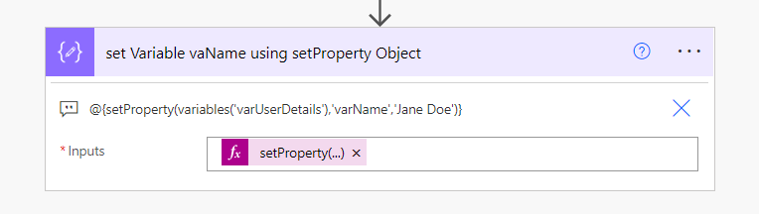

**Screenshot 3.** Make use of the **SetProperty** to update variables in the Object as show in **Note**

# **Make use of Scope Action to Group Actions**

The flow will have a lot of actions times, it affects the readability aspect of the flow. There exists an action called **Scope** in Power Automate. This action can be used to group the actions under one scope. This helps to reduce the confusion among the developers.

The screenshots below show the usage of the same.

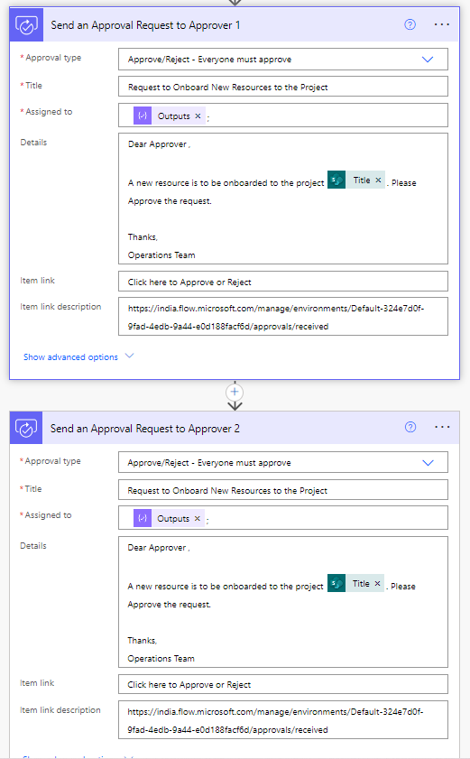

**Screenshot 4.** Both the Actions are related to an Approval Process, Approval is Required form both the Users

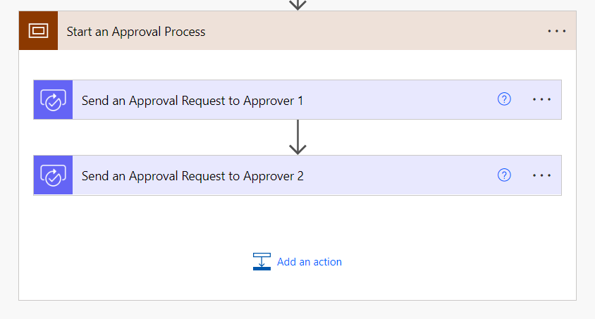

**Screenshot 5.** Making Use of Scope Action to Group the Approval actions together.

# **Use the Rename , Comments and Notes Action in Power Automate**

Power Automate has an option to include notes and comments for each action and trigger, this is a very helpful feature to include comments and notes for each action. We can make use of the **Comments** option to specify the expressions and use the **Notes** action to mention to comments to describe more about the specific action. More details given below.

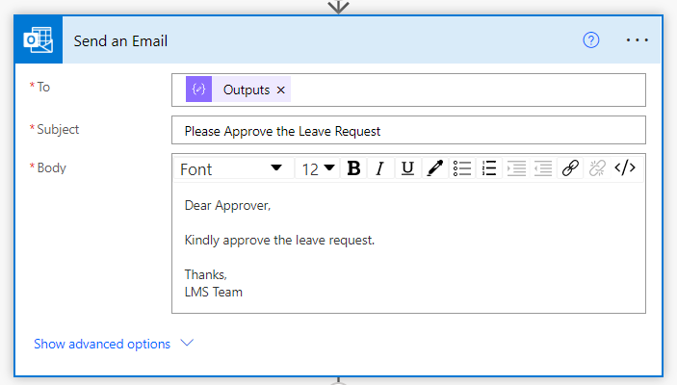

**Screenshot 6.** Screenshot showing the Send an Email Action

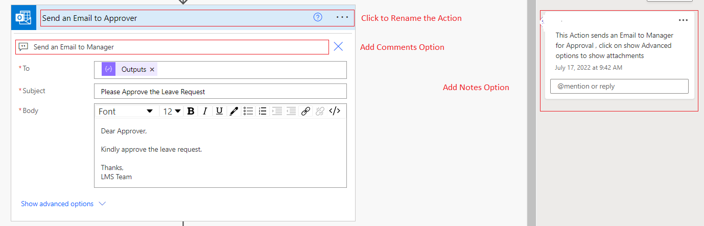

**Screenshot 7.** Screenshot shows how to make use of the Rename action, Add Notes option and Comments option effectively.

In the above screenshot , we can see that the action has been renamed , notes and comments are specified which makes it more easier to understand the flow.

# **Using the Select Operation/Action**

When we want to Update a multi-select choice column (Checkboxes) , we can use the Select Operation to get rid of apply to each. The Select Action helps to select directly the property that we want to use to update the column or create item in a New list.

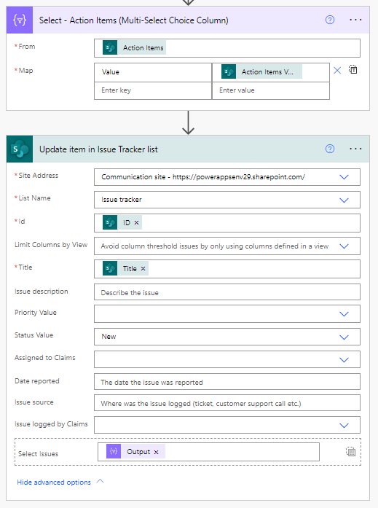

**Screenshot 8.** Screenshot shows how to use the Select property to Update the Item in one step

As shown in the above screenshot the select method helps to update the item in one step directly. rather than using the traditional method in which we append the values to an array variable and then enter into an **apply to each loop and then use that variable to update the value.**

# **Use Templates in Power Automate to Create Flows**

Power Automate has a lot of existing flow templates. These templates are in different categories as shown in the below screenshot.

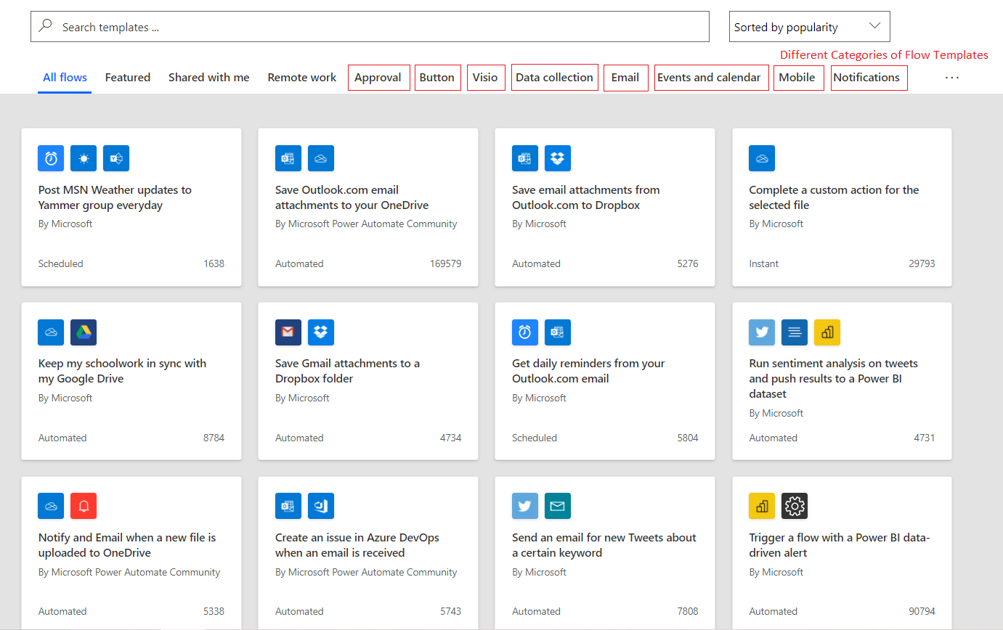

**Screenshot 9.** Screenshot showing different categories of Flow Templates

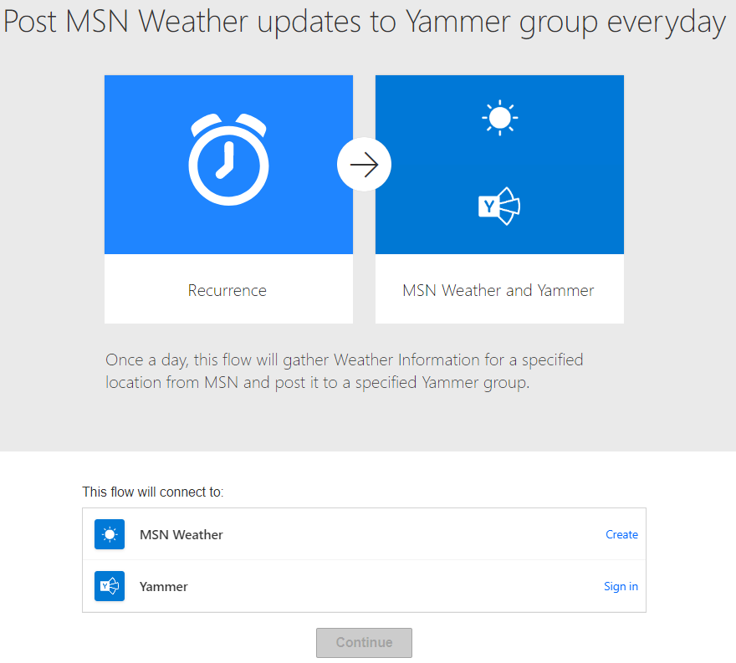

**Screenshot 10.** Select the Template to Create the flow

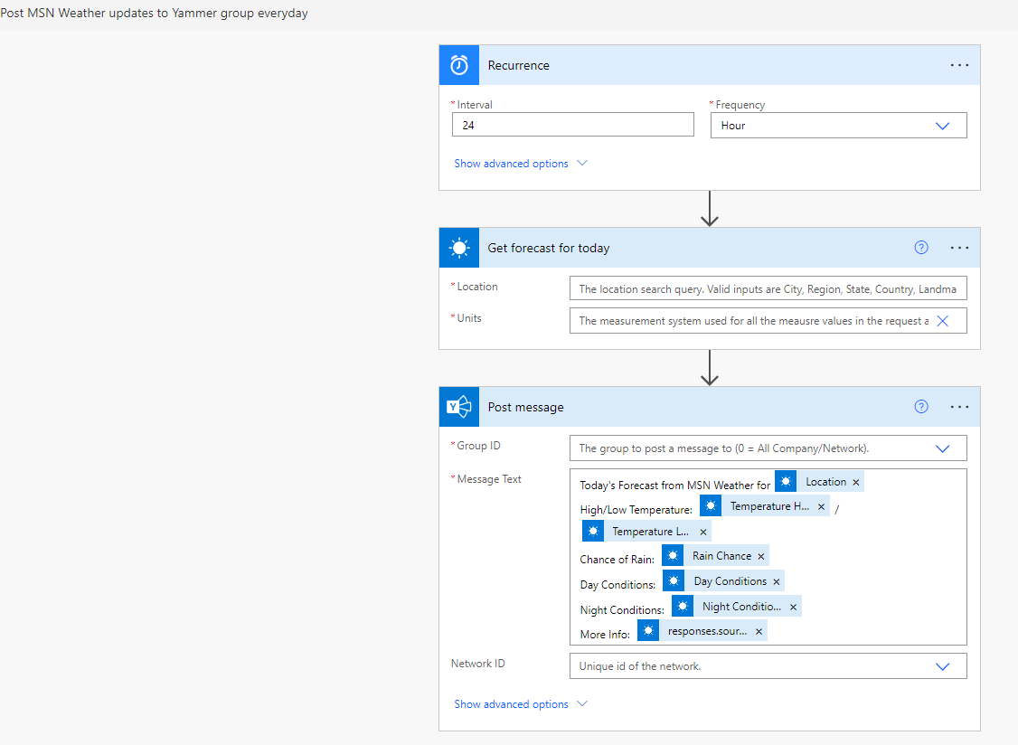

**Screenshot 11.** Template Flow to Post Weather Update to Yammer group Every 1 hour

# **Skip Option in Power Automate**

Power Automate, allows us to create different types of flows, which are as follows.

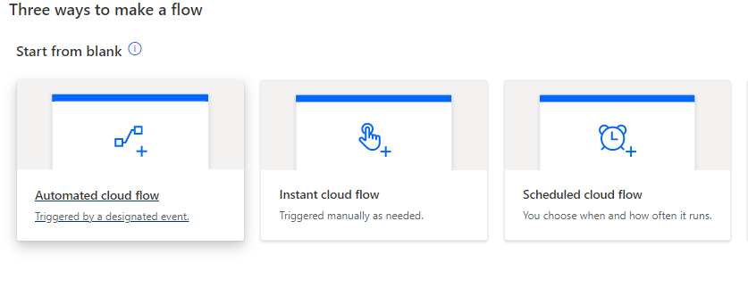

**Screenshot 12.** Different Types of Flows

It asks us to select the type of flow while creating. But if we are unsure of the type while creating we can select any option and skip creating that type of flow.

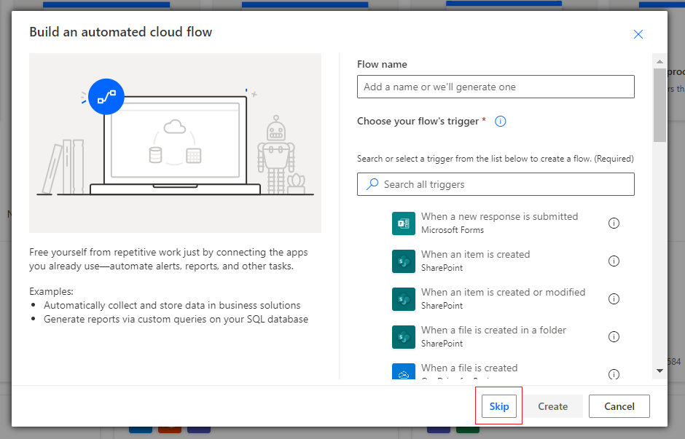

**Screenshot 13.** Screenshot showing the Skip button

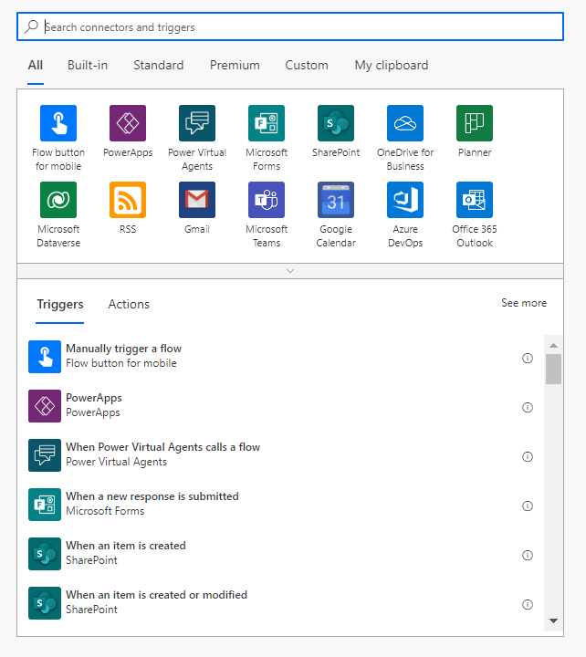

**Screenshot 14.** Page showing Option to Select any trigger after the Skip button

# **Search Connector Option in Power Automate**

There are a huge number of triggers in Power Automate , it will be very difficult to scroll through them and select. But the flow gives an option to search the trigger and action through the search option. The examples for the same are shown below.

The below screenshot shows triggers , in the same way we can search and use the actions also.

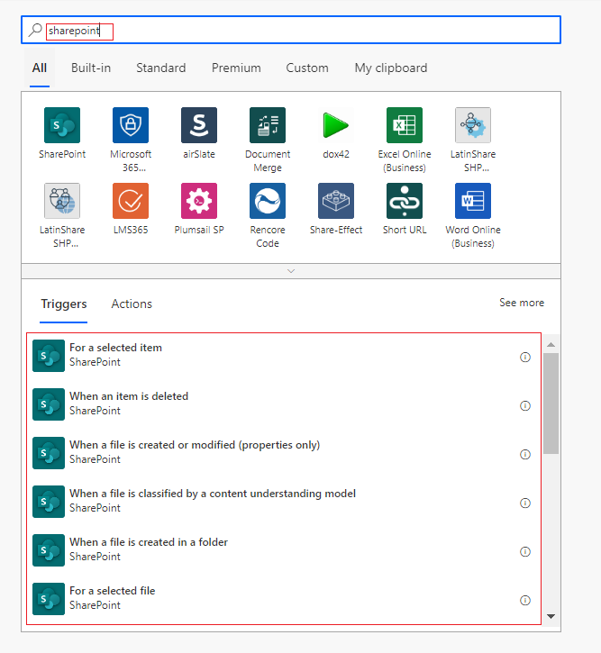

**Screenshot 15.** Page displaying triggers related to SharePoint

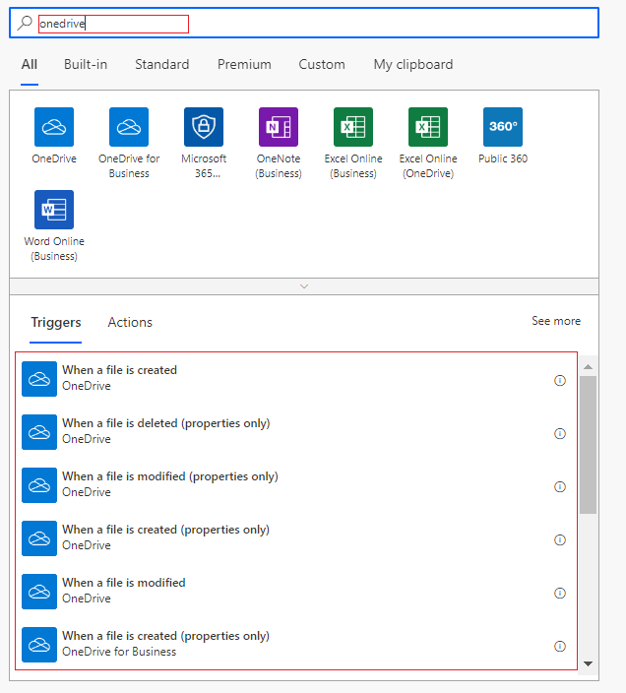

**Screenshot 16.** Page displaying triggers related to OneDrive

# **Copy to Clipboard Option**

Sometimes we want to remove and re-add the actions, but if we delete an action, it will be a time taking process to recreate the whole action .

For **example**, actions such as **Create Item, Update Item etc.,** where we might have a lot of columns to update . But if we have an option to save the already created **update item** or **create item** action we can copy that action to clipboard and reuse it. The screenshot shows the same.

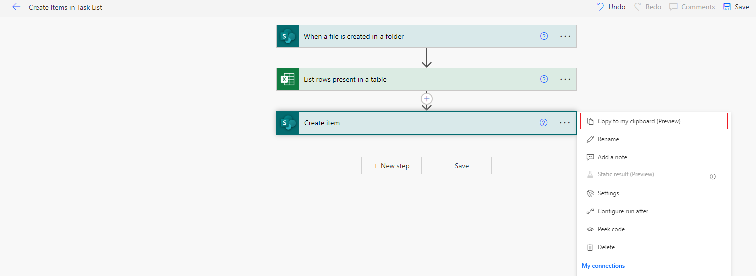

**Screenshot 17.** Screenshot displaying **Copy to Clipboard** option

We can make use of Copy to Clipboard option and copy and keep the action in the clipboard and use it for the next steps. This saves the action for that particular session.

Now click on New Step and Create the same action from the Clipboard by selecting as shown below.

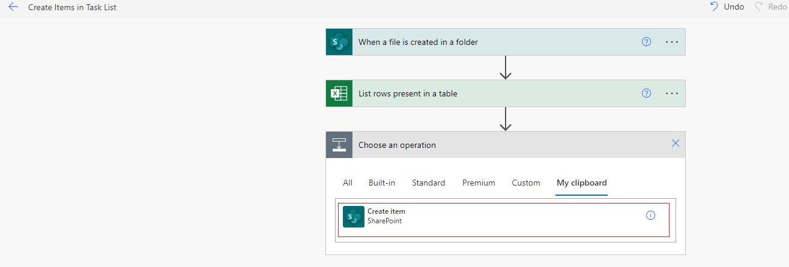

**Screenshot 17.** Clipboard Showing already copied Create Item Option

**Note :** Alternatively we can Copy and save the whole string into a notepad and Paste it in the My Clipboard section to copy and select that action.

# **Testing the Flows**

Once we develop the flow, we have to run and test it . Power automate provides two options to test the flows that we have created. One way is to perform the actual trigger and the second option is to use an option from a previously run trigger.

Also, we have an option to run the **scheduled** and **button flows** Manually directly by making use of the **Test Flow** option and test them.

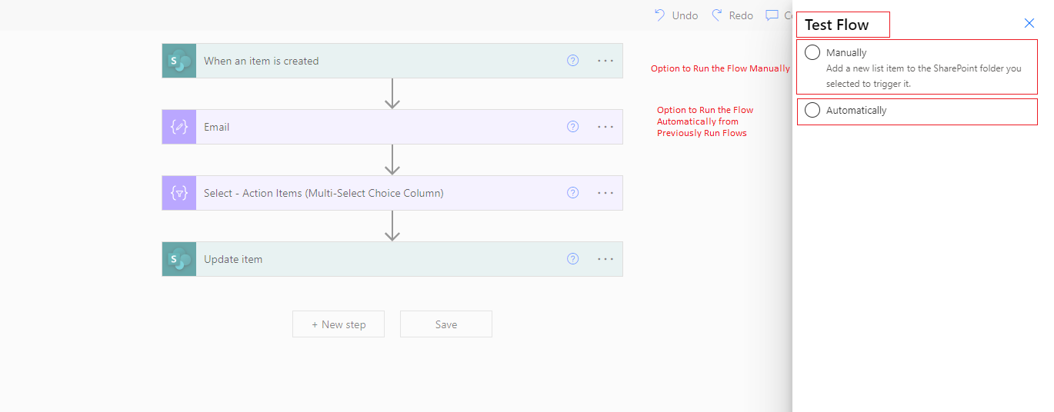

**Screenshot 18.** Screenshot showing different options to run the flow

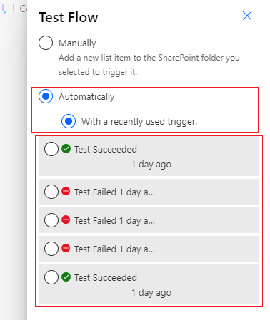

**Screenshot 19.** Screenshot showing previously run flows and an option to select the previously run flow and test.

# **Share the Flow with Other Users**

Power automate, by default considers the Creator of the flow as the Owner and creates the connections to the connectors with the signed in User’s Account.

If we want to give other users an option to edit and view your flow, you can share the flow with other developers by using **share Option** and share it with other users. This now allow the other users to make changes to the flow, check the run history and also change the connections to his/her account.



**Screenshot 20.** Screenshot to show the Share Option

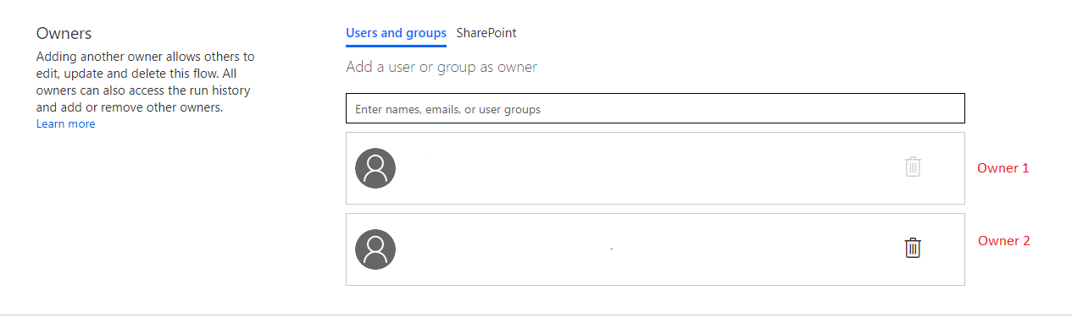

**Screenshot 21.** Screenshot showing Multiple Owners of the flow after sharing the Share Option of the Flow.

# **Making Use of Nested If Statements with Expressions in Power Automate**

We can make use of the condition action to check specific conditions in flow. But it may not always be a good idea to make use of the condition operation to check multiple conditions, in such a case we have an option of using Nested if statements using expressions.

For examples, if we are reading an Excel file data in Power Automate , we get the Date in 12-Jan-2022 , in this format , now we can make use of the Nested if Statement to get the Month, as shown in the below image.

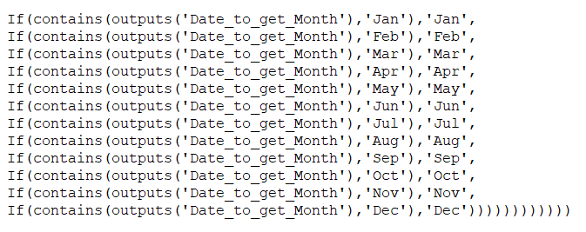

# **Option to set the Pagination limit and Timeout in Flow**

When we are dealing with SharePoint and Excel connectors and want to read data using **Get Items** action or **List rows Present in a table action** , it by default returns the first 256 items. If we were to change this limit , then we can go to **settings,** and set the **Pagination limit** of up to **100000** for premium licenses and up to a maximum of **5000** items for non-premium licenses.

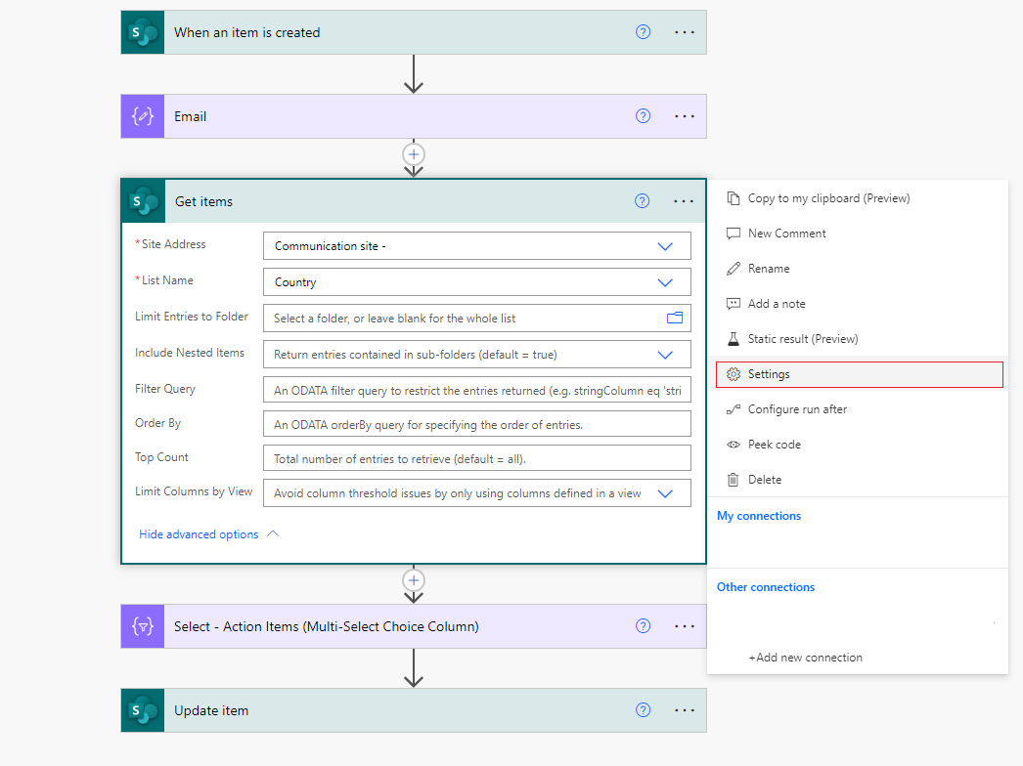

**Screenshot 22.** Screenshot showing the Settings Option to Open the pagination Option for Get Items Action

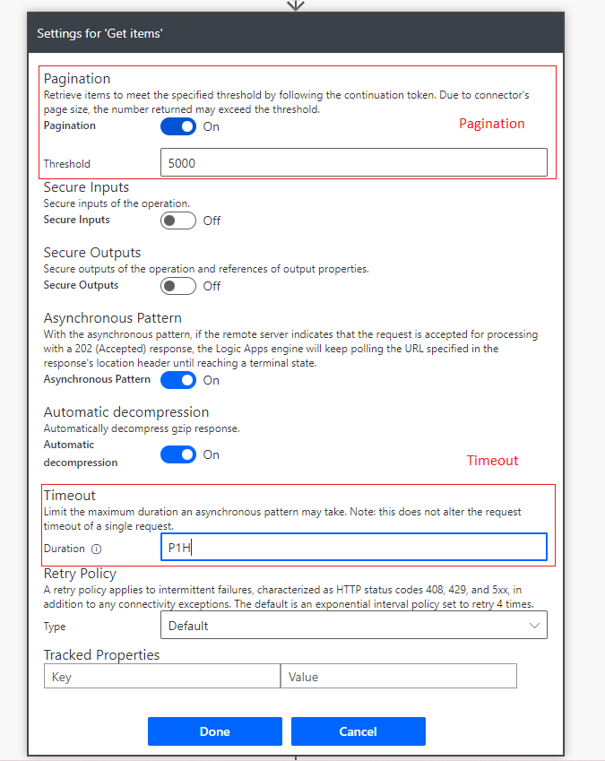

**Screenshot 23.** Screenshot showing the Settings Option to Open Turn on and Set the **Pagination** and to Set the **Timeout in ISO 8601 format**

# **Error Handling in Flow**

Every action in Power Automate runs by default when the previous action has run successfully, but this can be managed by making use of the

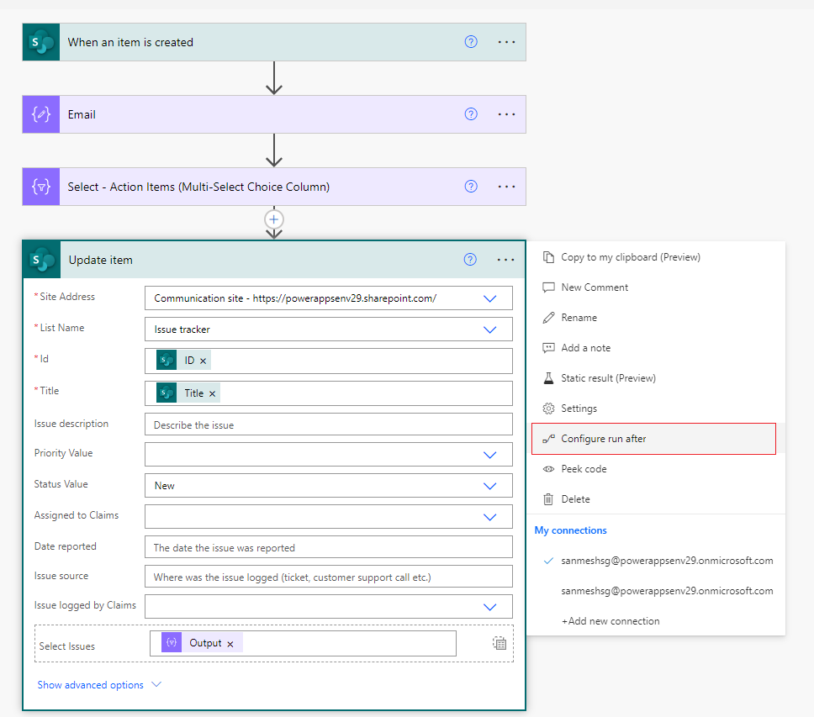

**Screenshot 24.** Screenshot showing the Configure Run After Option to Manage Error Handling

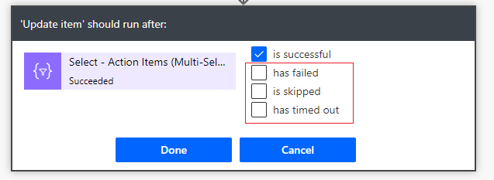

**Screenshot 25.** Different options to handle Errors

We can check the has failed option , and the flow would run even if the previous step has failed. We can **has timed out** , option to run the current step if the previous step of the flow has timed out.

# **Experimental Features in Flow**

We make use of expressions in the flow extensively. Whenever we have long expressions , it makes it difficult to understand , the previous part of the expressions , See the screenshot below to see how the expressions pane looks like.

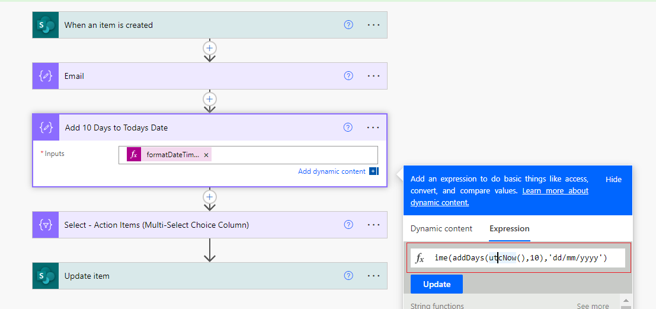

**Screenshot 26.** Screenshot shows writing Expressions with Experimental Features turned off.

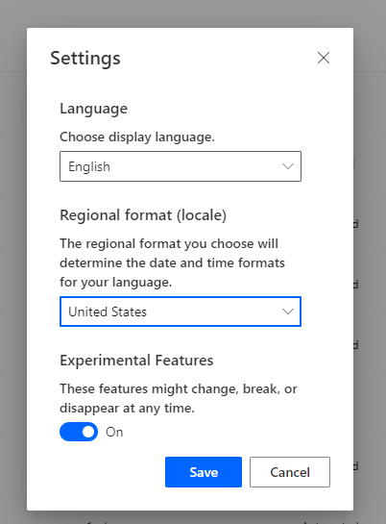

**Screenshot 27.** Screenshot showing turning on the Experimental Features in Flow from **Settings**

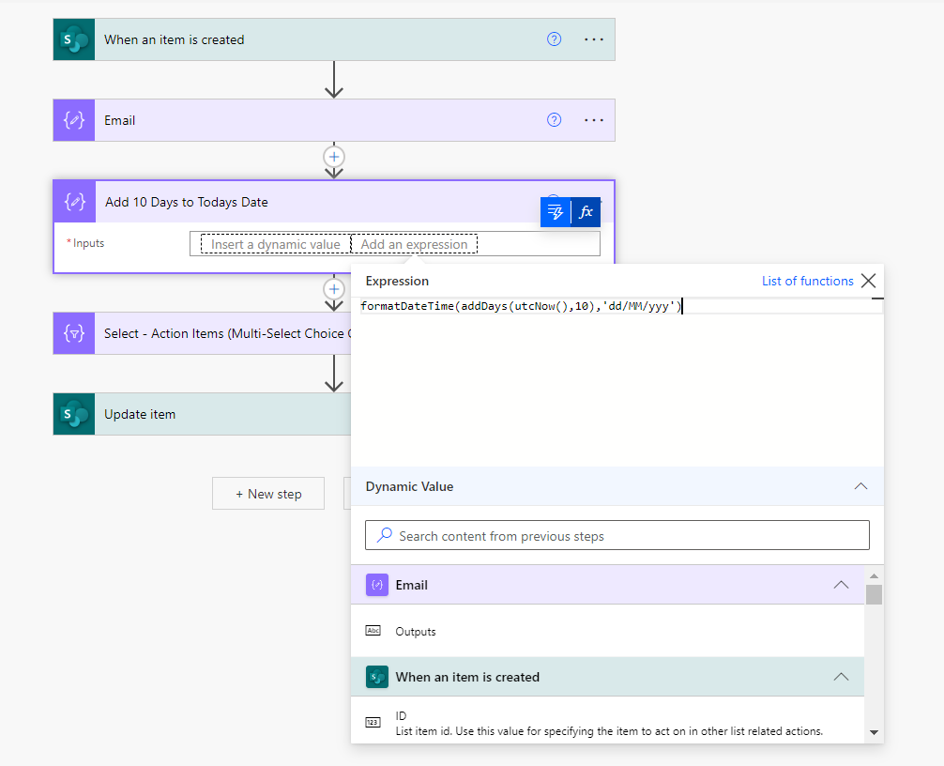

**Screenshot 28.** Screenshot shows how with Experimental features turned on it give more clarity on the readability of the expressions

# **Export and Import Flows**

This is an extremely useful feature when we want to move the Flow to different Environments. We can Export the flow to download the Zip File.



**Screenshot 29.** Screenshot shows how to Export any Flow

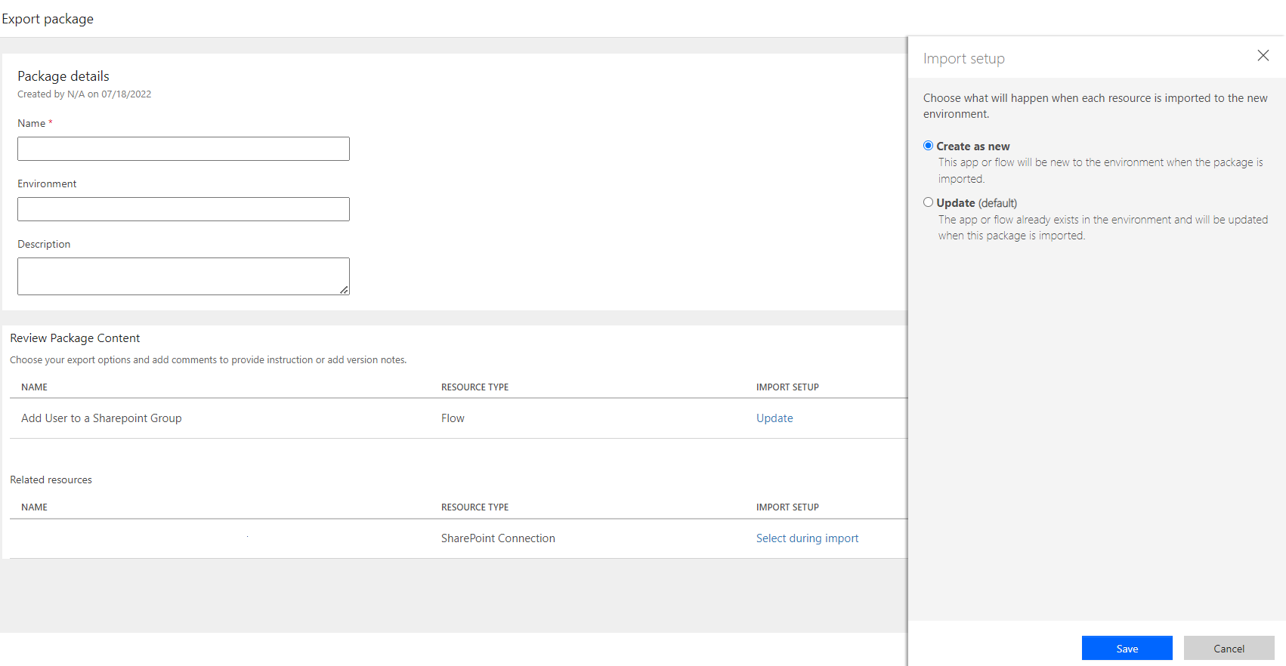

**Screenshot 30.** Screenshot shows how to Export the Flow with Create as New Option , similarly we can import any flow from the Zip file of other flow and create it.

# **Flow Checker**

The flow checker shows the warning whenever we are building the flow, and there are some things which can be helpful. For E.g., **Filter Query in Get Items action, Warning for Update item action etc.**

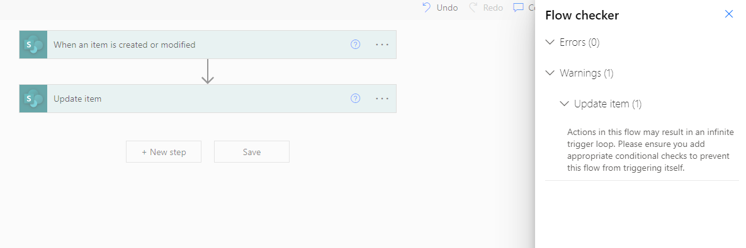

**Screenshot 31.** Screenshot showing the warning to avoid infinite loop

# **Use Compose Action**

Whenever we want to perform any action, we can make use of the Compose action instead of making use of variables. This helps to reduce the number of steps of the flow , as if we use variables we first have to initialise them and then set a value. But using Compose action we can directly perform the operation.

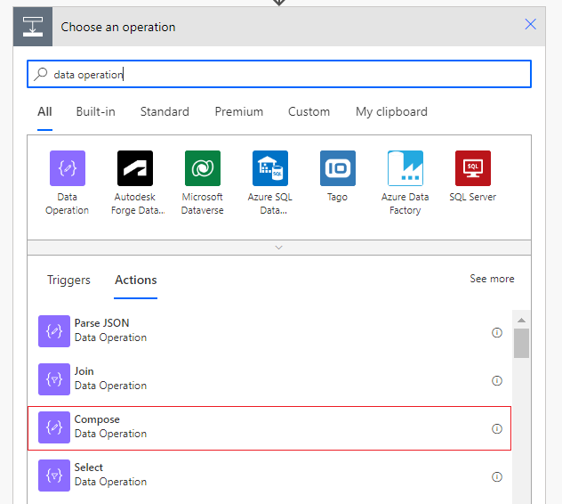

**Screenshot 31.** Screenshot shows the Data Operation and Compose

# **Commonly Used Expressions to Access values**

1. **From Variables** : To get data from variables defined in a flow , we can make use the below expression.

**Variables(‘varYearsofExperience’)**

1. **From Trigger** : To get data from trigger in a flow , we can make use the below expression.

**triggerBody()?[‘ID’]** – gives the data from the ID Column

**triggerBody()?[‘Status/Value’]** – Get the data from a choice Column

1. **Inside an apply to Each Loop** : When we are inside an apply to each loop we can use the expressions which could be as below. Apply to each could vary depending on the name of the loop we have specified.

**Items(‘apply_to_each’)?[‘ID’] –** Gets the ID Column in the loop

# **Parallel Branching**

We often want to run two actions simultaneously in flow. While doing so one needs to ensure that there is no dependency on other branches. Power Automate gives an option to run two actions parallelly as depicted.

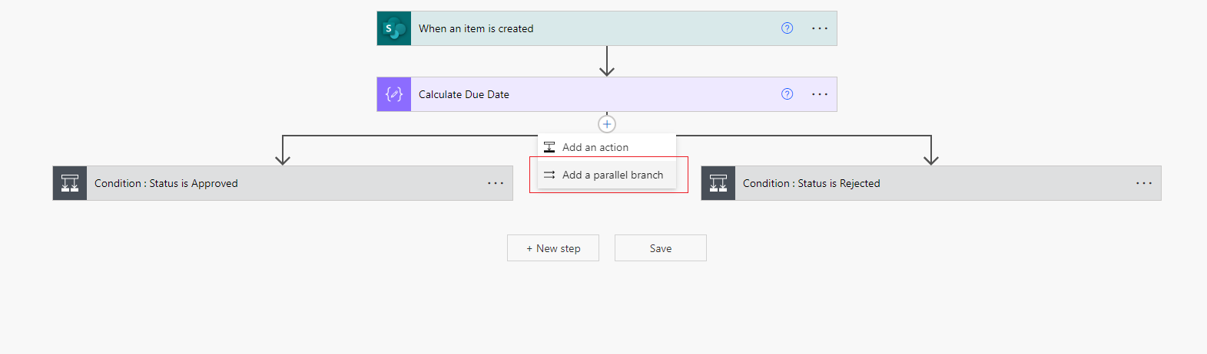

**Screenshot 32.** Screenshot showing the Parallel Branching

# **Concurrency Control**

If we want to perform any operations inside an apply to each loop, Create Item , Add a row etc. We can turn on the **Currency Control feature** and Set the limit to **50** , this ensures that more processes are run parallelly at a time , and the flow would take less time to complete the execution.

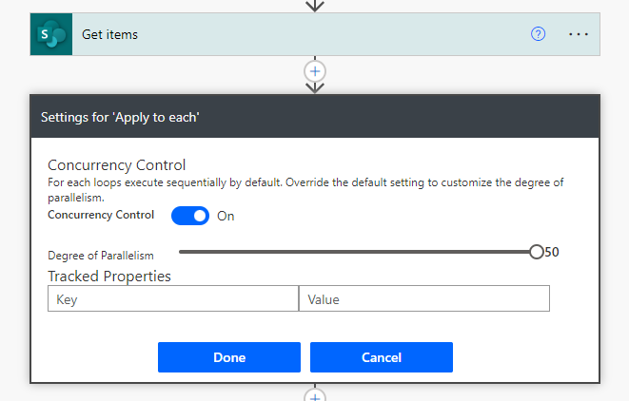

**Screenshot 33.** Screenshot showing the Concurrency Control feature

# **Flow Trigger Conditions**

We can make use of the Flow Trigger Conditions from the Setting option of the Trigger.

This helps to have a condition defined for the trigger itself rather than defining the condition explicitly using the condition option.

The Screenshot below shows the same. The flow in this Case runs/triggers only when the value of the **ApprovalRequired** column is **Yes**.

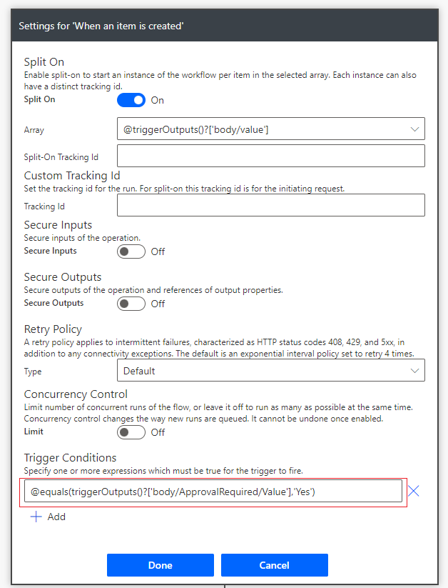

**Screenshot 34.** Screenshot showing the trigger conditions option

# **Use Peek Code to Copy the Expressions**

To Copy expressions from any of the action we can make use of the **Peek Code** Option from settings.

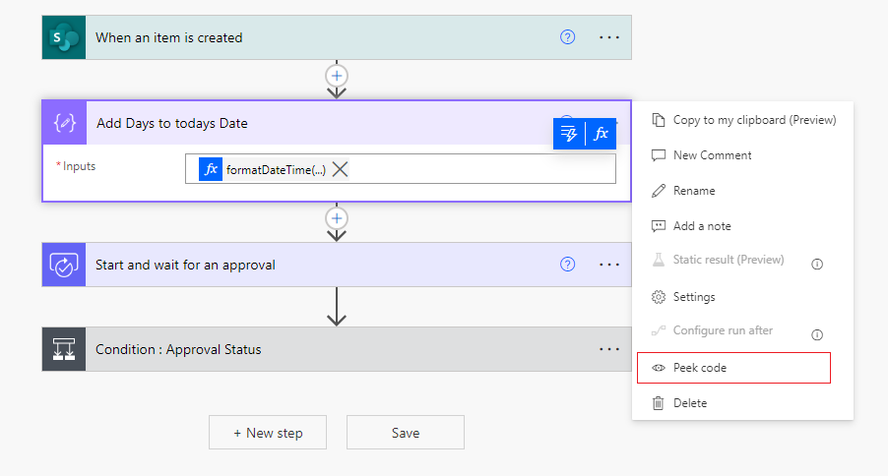

**Screenshot 35.** Screenshot showing **Peek Code** Option

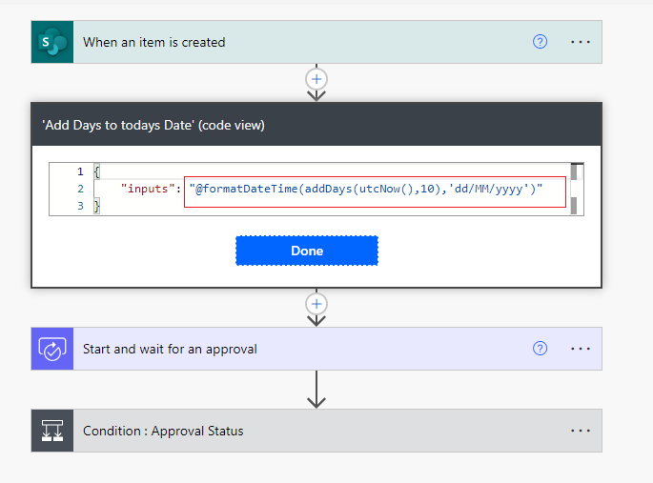

**Screenshot 36.** Screenshot showing **Peek Code** Expression

We can copy this expression from the peek code , remove the @ and {@ if any and use them in the flow.

# **Number and Currency Formatting in Flow**

We can use the Format Number option to convert the number into any specific format. This action or operation can be used in two ways , one way is to use the Format Number action and the second way is to use the expression **formatNumber(number , string :locale , format string)** , by using this syntax.

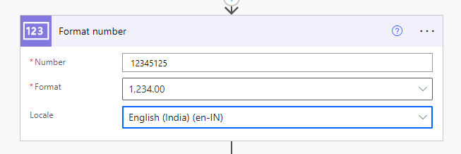

**Screenshot 37.** Screenshot displaying the **Format Number** Option

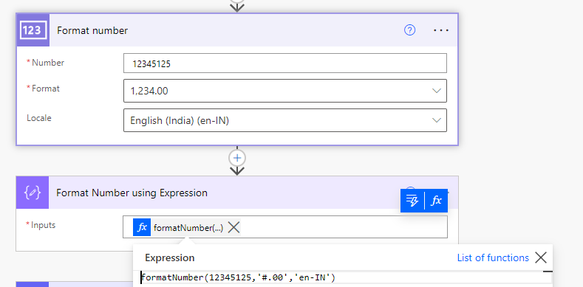

**Screenshot 38.** Screenshot displaying how to use the Expression to **Format the Number**

Using a similar action , we can format the currency also. We need to select/pass the correct option in the format.

# **Date and Time Formatting and Converting Time Zones in Flow**

Flow has options to Add Time , Get Past time , Convert Time Zone , Subtract time. This is one the most powerful and helpful features of flow.

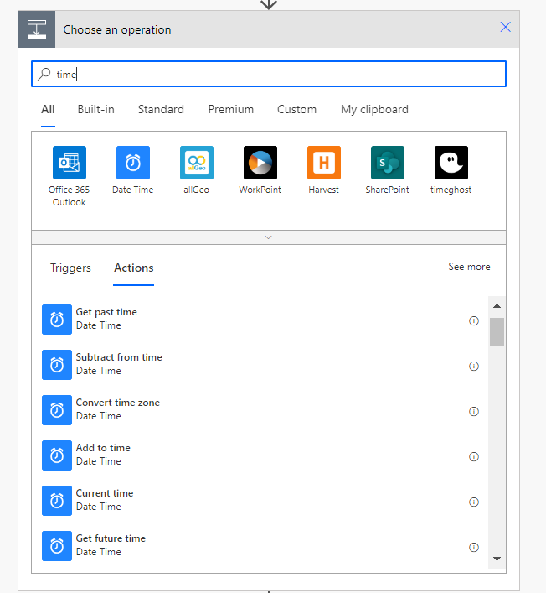

**Screenshot 39.** Screenshot displaying different Time related Actions

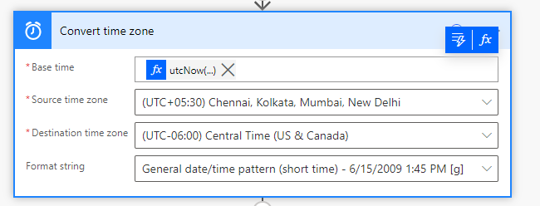

**Screenshot 40.** Screenshot displaying Converting Indian Time to US Central Time

In the same way we can use other actions and perform the other operations. Some of these operations can be done using expressions also.

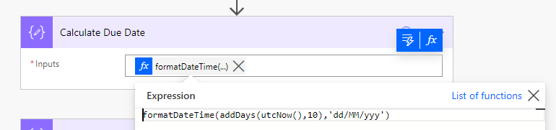

**Screenshot 40.** Screenshot displays adding 10 Days to Current time and Formatting the Date in dd/MM/yyy format.

# **Flow Run History**

The flow shows a 28 days run history. We have an option to download the run history in CSV format.

Also we have an option to filter the flow runs based on whether a run is **Successful, Failed or Cancelled.** Downloading the Flow Run History can be automated using Power Automate Desktop.

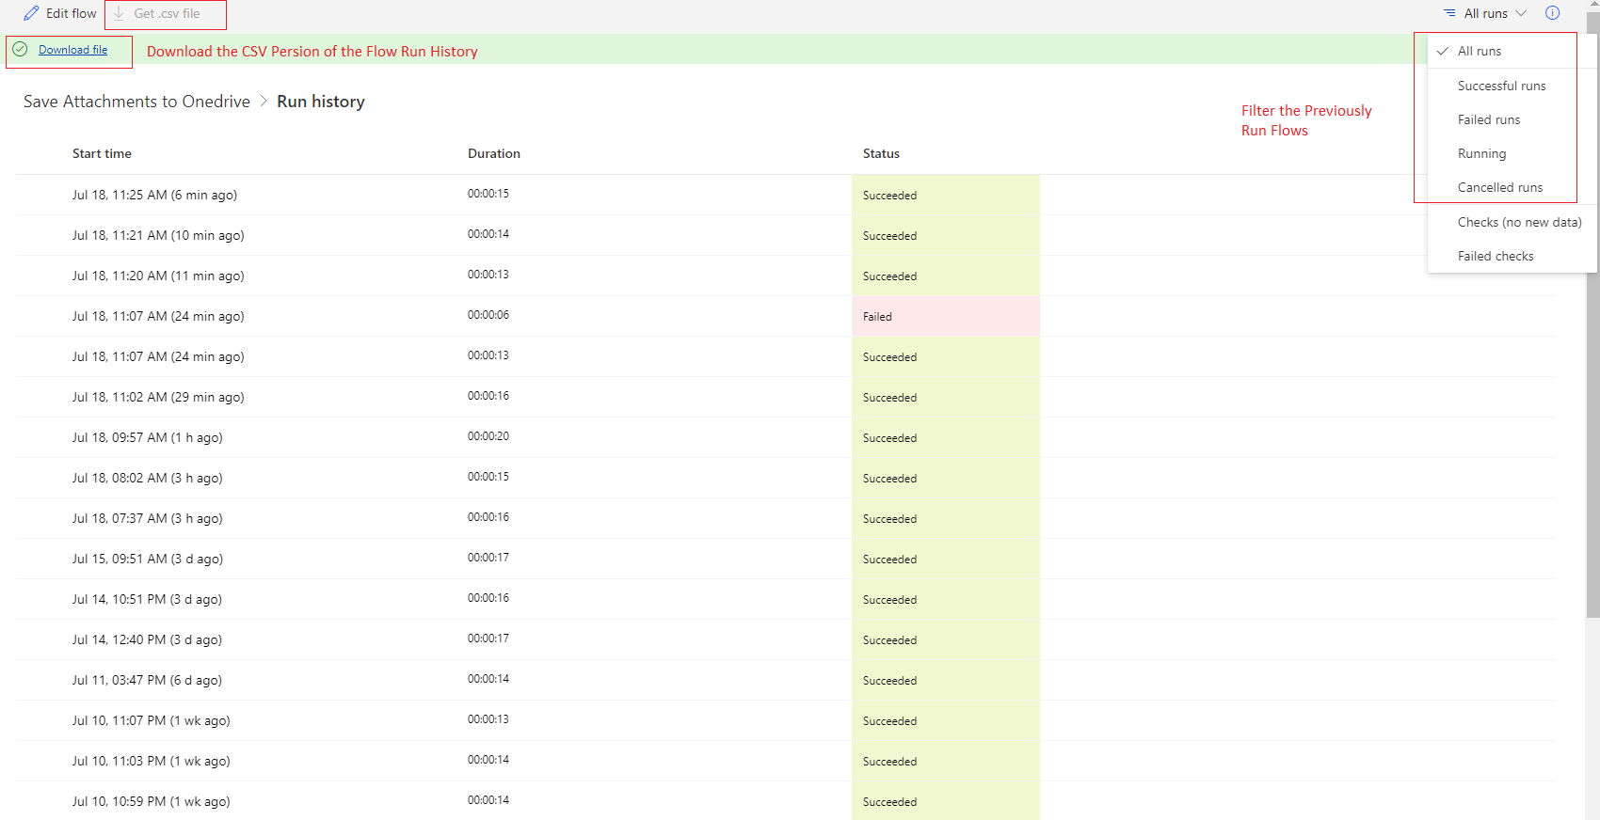

**Screenshot 41.** Screenshot displays the Flow Run History

**Bonus Tips**

* Hover on the flow Dynamic Expressions in flow to view the expression.
* The Flows which are created as Cloud Flow are shown under **Cloud Flows** **section** and the flows that have multiple Owners are listed under **Shared with me.**

**Document Version History**

|  |  |  |  |  |
| --- | --- | --- | --- | --- |
| **S.No.** | **Version No.** | **Date** | **Prepared By** | **Signed off By** |
| 1 | 1 | 18/7/2022 | Steve |  |
|  |  |  |  |  |
|  |  |  |  |  |
|  |  |  |  |  |